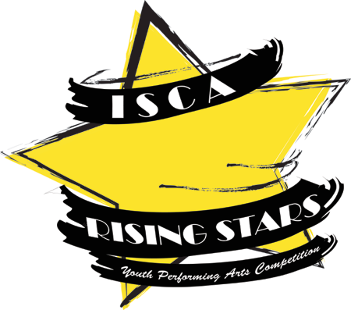
2016 ISCA RISING STARS RELEASE AGREEMENT AND INFORMATION SHEET

I, (parent or guardian of) _____________________, who is a ___ grade student in southern Beaufort County (the “Contestant”), authorize the Island School Council for the Arts a not-for-profit arts organization, its assigns, and those acting with its authority (collectively, “ISCA”), to make, or use, materials in any form or medium, but not limited to printed, recorded, audio, audiovisual material bearing or containing the Contestant’s “Name and Likeness” (defined below) and made before, during, after or in relation to ISCA’s Rising Stars competition including, but not limited to outtakes, and interviews.
On behalf of the Contestant, I hereby waive all rights and claims under privacy, publicity, defamation, compensation and proprietary rights law relating to the Works and acknowledge ISCA’s right to use these materials for arts education marketing and fundraising efforts.
I acknowledge that the Contestant is competing to receive cash in the Competition. I will not hold ISCA liable for the breach of any agreement previously made or herein made as a result of the Contestant’s participation in the Competition or related events.
I acknowledge that the information (physical and email addresses) that I share with ISCA and its trusted third Party Partners may be used to market products and/or services related to youth performing arts and arts education.
I hereby forever release and discharge ISCA and its officers, and any party that is affiliated with, sponsors or organizes the Competition from liability for loss or theft of articles left in changing rooms, and the performance space, and injuries sustained by the Contestant while participating in this event. I acknowledge that the Contestant attends this event at his or her own risk. I will defend, indemnify and hold ISCA and its officers and directors harmless from and against any and all claims, demands, losses, suits and expenses relating to this Release Agreement arising out of my actions or negligence. This Consent and Release does not in any way conflict with any existing commitment on the part of the undersigned.
I represent that I am the legal guardian and/or parent of the Contestant and that I have the right, power and authority to enter into this Release Agreement.

Name of Parent/Guardian (please print): __________________________________

Signature of Parent/Guardian: __________________________________________ Date: _____________

Name of Act: Type of Act:

Length: Number of Participants:

List of all participants is required:

Name: Age: Grade: Email: Phone#:

Name: Age: Grade: Email: Phone#:

Name: Age: Grade: Email: Phone#:

Name: Age: Grade: Email: Phone#:

Name: Age: Grade: Email: Phone#:

Name: Age: Grade: Email: Phone#:

Name: Age: Grade: Email: Phone#:

Name: Age: Grade: Email: Phone#:

Name: Age: Grade: Email: Phone#:

Name: Age: Grade: Email: Phone#:

Please list any and all Technical Needs for the Act:

# of standing Microphones:____ # of handheld Microphones #of Music Stands____ #of Chairs____

List any specific type of musical instruments or props used in your act:

List any specific needs for lighting or sound: (such as music starts before we enter, fade out music/lights or blackout at the final pose) Please include any entrances or exits in your specifications. We will email you for more detailed specifications if selected to perform.

Email the completed form to Patti Maurer at pmaurer@isca-online.org
No video entry will be judged without this form. Call 843-263-5346
